METROFARE
UML & System Design Document
Case Study 12 • Automatic Fare Collection Across Three Operators

Project Type | Software Engineering / UI Prototype
Primary Focus | Cross-operator integration and interface ownership
Operators | Line A • Line B • Line C
Design Principle | Common MetroFare interface + operator-specific adapters

1. System Overview
MetroFare provides a common automatic fare-collection layer for three independent metro operators. Each operator may use a different gate protocol and maintain its own records. The design isolates those differences behind adapters and provides a shared journey, fare, settlement and audit flow.

1.1 Core Cross-Operator Journey
Example: a commuter taps in on Line A and taps out on Line C using the same fare card.
- 1. Tap-in is received from Operator A.
- 2. Adapter A converts the operator protocol to the MetroFare format.
- 3. MetroFare records the journey.
- 4. At Line C, Adapter C converts the tap-out event.
- 5. MetroFare calculates and deducts the fare once.
- 6. The journey becomes part of the settlement ledger.

2. Use Case Diagram
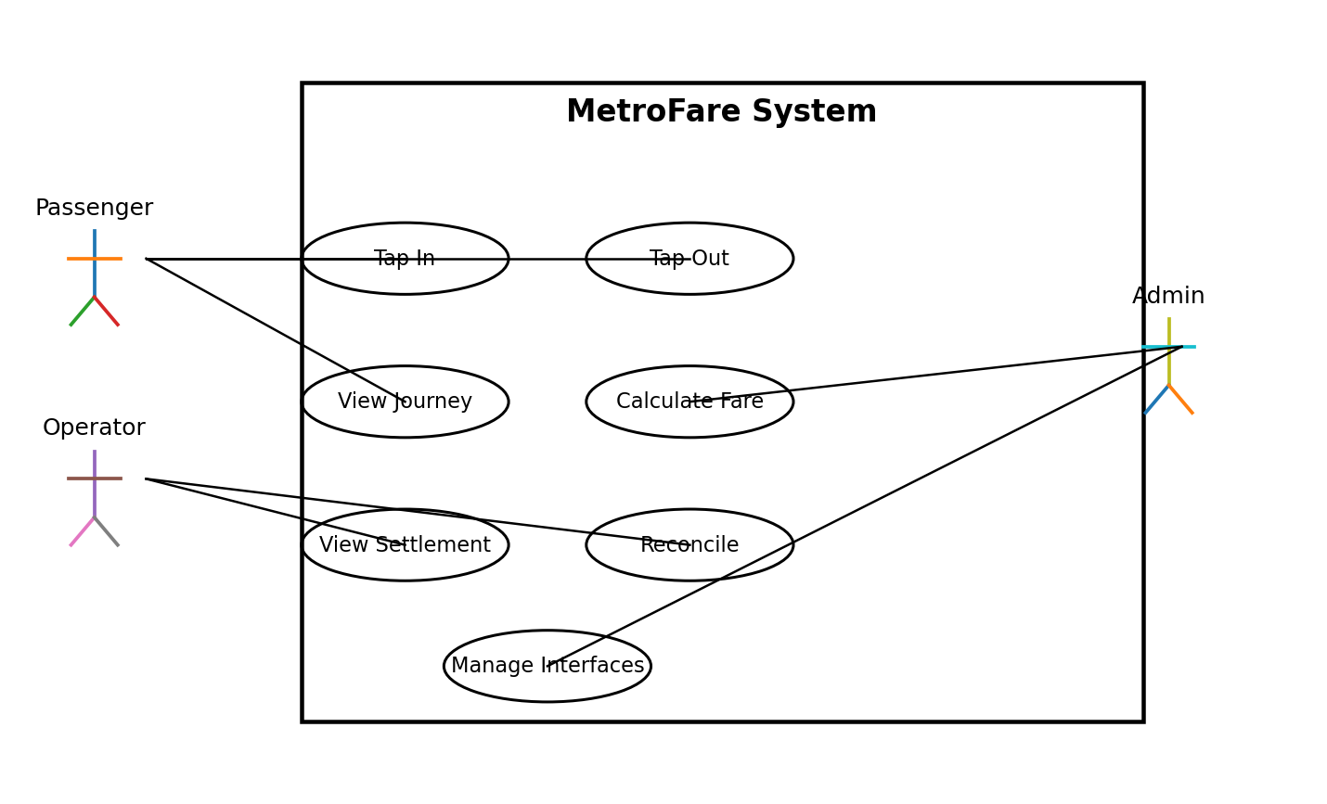
Figure 1 — MetroFare use cases
The use-case view identifies the passenger, operators and administrator as the main actors. The key user-facing actions are tap-in, tap-out, journey tracking and settlement/reconciliation.

3. Class Diagram
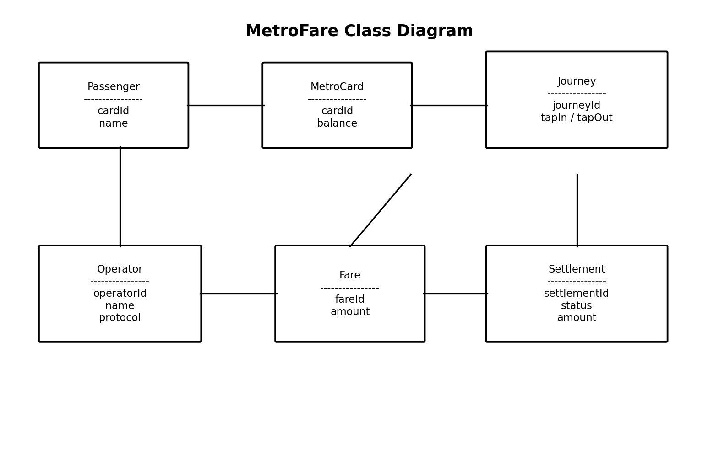
Figure 2 — Core MetroFare domain classes
The class view captures the core information handled by the system. MetroCard belongs to a passenger, Journey records the trip, Fare represents the calculated charge, Operator identifies the participating organisation, and Settlement represents the reconciliation record.

4. Activity Diagram
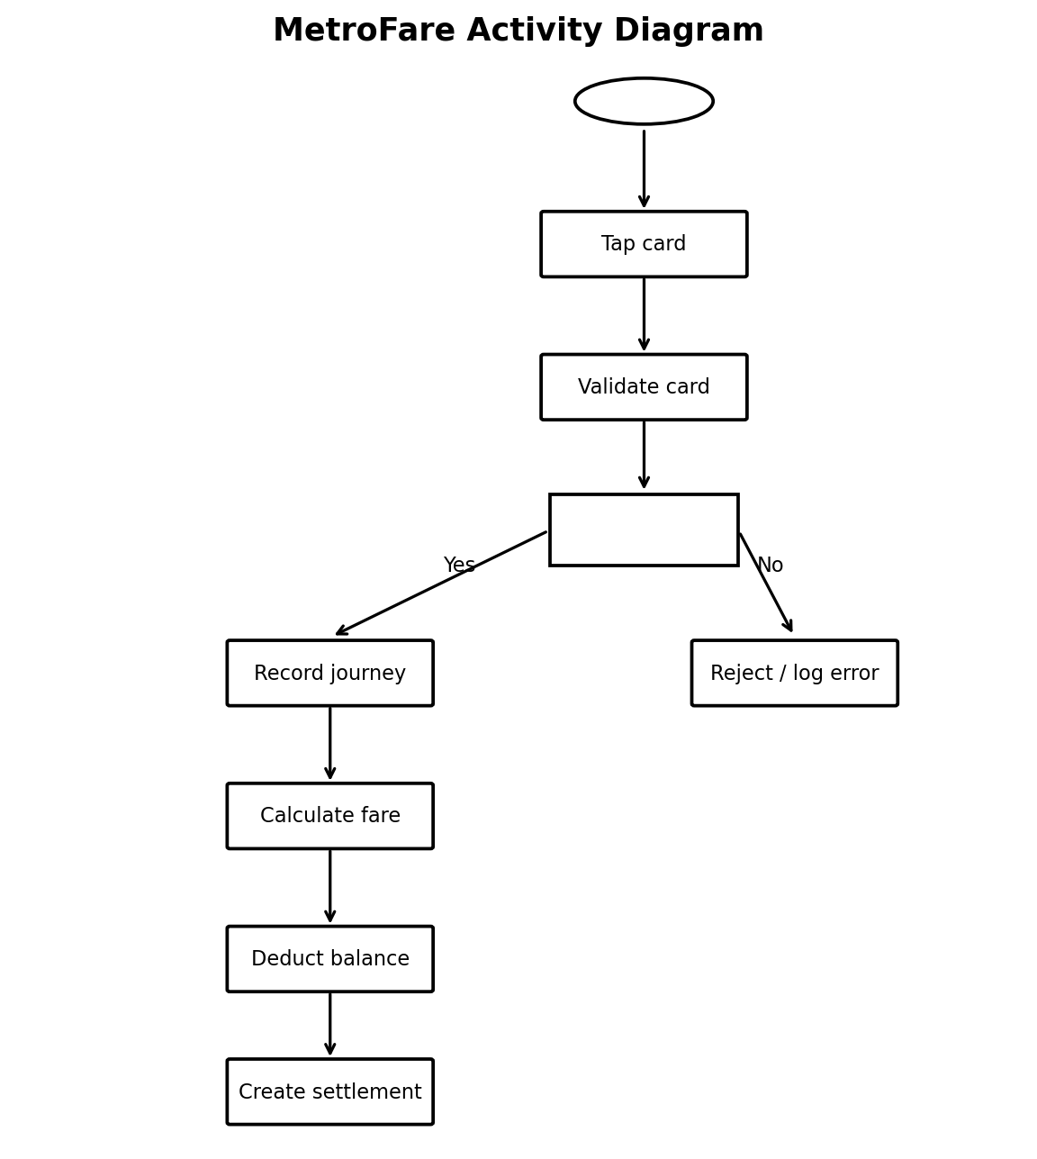
Figure 3 — Fare transaction activity flow
The activity flow validates the card before recording a journey. Invalid transactions are rejected and logged. Valid transactions proceed through fare calculation, balance deduction and settlement creation.

5. Cross-Operator Sequence Diagram
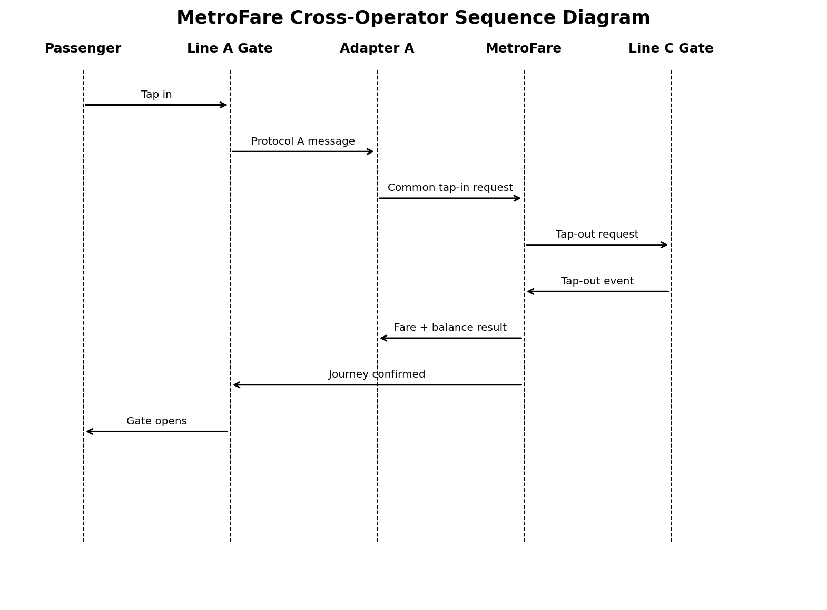
Figure 4 — Example Line A to Line C journey
This is the most important UML view for the case study because the historical failure was caused by weak interface testing. The sequence explicitly shows the hand-offs between a gate, an adapter and the central MetroFare service.

6. Deployment Diagram
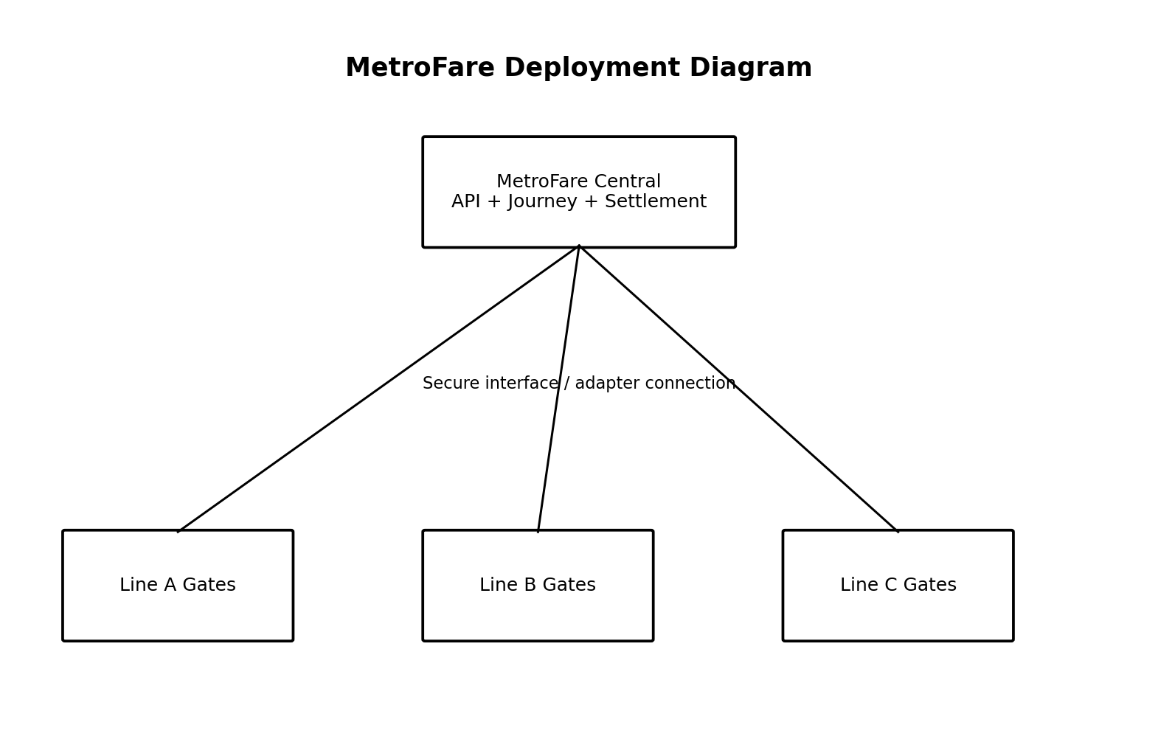
Figure 5 — Logical deployment view
The deployment view separates operator-side gate infrastructure from the central MetroFare services. In a production implementation, each operator's protocol would terminate at its adapter rather than leaking into the core system.

7. High-Level Design (HLD)
The HLD describes the major components and their relationships:
- Operator A gates → Adapter A → MetroFare
- Operator B gates → Adapter B → MetroFare
- Operator C gates → Adapter C → MetroFare
- MetroFare → Journey/Fare/Settlement services
- Shared interface specification governs all three adapters

8. Low-Level Design (LLD)
The LLD explains the internal responsibility of each adapter and service. A typical adapter contains:
- Protocol parser / message decoder
- Message validation
- Operator-to-common data mapping
- Error translation
- Common MetroFare API handler

9. Interface Ownership
Interface | Primary Owner | Participants | Purpose
Operator A ↔ MetroFare | MetroFare Integration Lead | Operator A + MetroFare | Tap events and acknowledgements
Operator B ↔ MetroFare | MetroFare Integration Lead | Operator B + MetroFare | Tap events and acknowledgements
Operator C ↔ MetroFare | MetroFare Integration Lead | Operator C + MetroFare | Tap events and acknowledgements
Settlement Interface | Settlement Lead | All operators + MetroFare | Daily reconciliation and dispute records

10. Integration Testing Focus
The recommended approach is incremental integration with explicit interface milestones. It is designed specifically to prevent the historical failure mode: each operator proving its own component works while the interfaces fail.
- Milestone 1 — Operator A adapter + MetroFare
- Milestone 2 — Operator B adapter + MetroFare
- Milestone 3 — Operator C adapter + MetroFare
- Milestone 4 — A-to-C cross-operator journey
- Milestone 5 — Full three-operator integration and settlement reconciliation

11. Key Non-Functional Requirement
Requirement | Target
Tap-to-open latency | < 300 ms at p99; offline fallback when central system is unreachable

12. Viva Quick Answers
What is UML? Unified Modeling Language; it visually represents the structure, behavior and interactions of a software system.
Why use an adapter? Each operator has a different protocol. The adapter converts it to one common MetroFare interface and reduces coupling.
Why is the sequence diagram important? It shows the exact order of messages in a cross-operator journey and makes interface ownership visible.
HLD vs LLD? HLD shows the major components and connections. LLD explains the internal details of those components.
Why incremental integration? Because the previous project failed when teams tested only their own components and not the interfaces between them.

13. Scope Note
This academic deliverable is a UI/prototype and design demonstration. It does not implement real metro hardware, real payment rails or production operator APIs. The diagrams describe the intended architecture and behavior.

